Attention Plant Managers and Young Professionals!
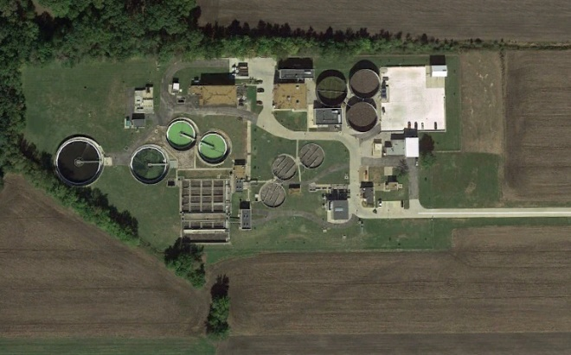


The Missouri Water Environment Association Plant Manager’s Committee and Young Professional’s Committee Presents:
A Networking Lunch & Plant Tour of the
Saint Charles Mississippi WWTF
4933 Dwyer Road, St. Charles, MO 63301 (636) 250-4600
Wednesday, November 20, 2019 11:30am
Lunch will be at Big A’s on the Riverfront, 308 N Main St, St Charles, MO 63301
bigasontheriverfront.com. (636) 949-9900
At 12:45 pm we will start a short presentation on the plant operations.
At 2 pm we will start the plant tour
Please consider bringing someone with you. This is a networking opportunity.

Directions to Restaurant:

Take I-70 west of St. Louis and west of the Mississippi River. Exit S. 5th St headed NE. Proceed to Monrow St and turn Right. Proceed to N. Main Street.

Directions to the WWTP:

From Big A’s, take Monroe back NW to N 2nd Street - turn right. Proceed on N 2nd Street to N 3rd Street/94 – take first right at roundabout onto N 3rd Street/94. Continue north to Highway B – turn left. Proceed on Highway B until Seeburger Road – turn right. Continue north on Seeburger Road until turning left into plant entrance.

Description:

The St Charles Mississippi River WWTF has a full headworks, pre-aerobic selectors, activated sludge with final clarification and UV disinfection prior to discharge. The Plant utilizes Gravity belt sludge thickeners and Presses for dewatering. Sludge is landfilled.
Mr. Steve Lawrence will present the program on the plant operations.
RSVP to 816-853-2910 or to mpearson@scsengineers.com so we can get a headcount!

